


Department of Information Science & Engineering

Report on

MAJOR PROJECT

Cloud-Native News and Supply Chain Data Driven Financial Market Prediction System

Submitted by
Nirvaan Nair (4NI22IS135)
Prasanna B S (4NI22IS152)
Preetham B (4NI22IS155)
Pushpak B V (4NI22IS160)

Under the guidance of

Mrs. Prathibha B S
Assistant Professor
Department of IS&E
The National Institute of Engineering, Mysuru.

THE NATIONAL INSTITUTE OF ENGINEERING
MYSURU- 571130, KARNATAKA, INDIA
2025-26



The National Institute of Engineering Department of Information Science and Engineering
MYSURU- 571130

Certificate

Certifies that the Major-Project titled “Cloud-Native News and Supply Chain Data Driven Financial Market Prediction System” is presented by Pushpak B V (4NI22IS160) Prasanna B S(4NI22IS152), Preetham B(4NI22IS155), Nirvaan Nair (4NI22IS135) in partial fulfillment for the requirements of the seventh semester BE in Information Science & Engineering prescribed by The National Institute of Engineering, Autonomous Institution under Visvesvaraya Technological University, Belagavi. It is certified that all corrections/suggestions indicated for Internal Assessment have been incorporated. The major project report has been approved as it satisfies the academic requirements in respect of the major project prescribed for the seventh semester.

Signature of Guide Signature of HOD
Mrs. Prathibha B S Dr. Girish
Assistant Professor HOD & Professor
NIE, Mysuru NIE, Mysuru
Signatures with dates
Name of the examiners:

1.

2.

The success and the final outcome of this minor project presentation required a lot of guidance and assistance from many people and I am extremely fortunate to have got this all along with the completion of the minor project presentation.
I express my profound thanks to Dr. Rohini Nagapadma, Principal, NIE, Mysuru for her much needed moral support and encouragement.
I am grateful to Dr.Girish HoD, & Professor, Information Science and Engineering, NIE for his support and encouragement in facilitating the progress of this work.
I sincerely extend my thanks to the major project presentation Guide
Mrs. Prathibha B S, Assistant Professor. I would like to sincerely thank my Co-Guide Dr. Rajeshwari D, Associate Professor in the Dept. of IS&E., for her guidance, technical expertise, encouragement, and timely help in making this work a reality.
Also, I would like to extend my sincere regards to all the non-teaching staff of the IS&E Dept. for their timely support.

Nirvaan Nair (4NI22IS135)
Prasanna B S (4NI22IS152)
Preetham B (4NI22IS155)
Pushpak B V (4NI22IS160)

ABSTRACT
In today’s dynamic financial landscape, accurate forecasting relies on the seamless integration of diverse data streams such as market indicators, logistics information, and real-time news. Traditional monolithic systems often encounter limitations in scalability, flexibility, and transparency, impeding their ability to process such complex inputs effectively. This report introduces a microservice-oriented financial forecasting framework engineered for scalable performance, interpretability, and continuous adaptability. Leveraging AWS S3 as a unified data repository, the architecture adopts a Bronze–Silver–Gold data lake hierarchy to ensure comprehensive data governance, traceability and reproducibility.

The use of rolling window learning enables adaptive modeling to address concept drift, while SHAP-based interpretability provides insight into the key variables influencing predictions. By integrating LightGBM for structured data analysis and FinBERT for sentiment extraction from textual sources, the system fuses multiple data modalities into a cohesive analytical workflow. Core technologies such as Python (Scrapy, Pandas, Scikit-learn), Docker, and Metabase enhance the framework’s modular design, cloud-native scalability, and visualization capabilities.

The proposed framework establishes a future-ready foundation for intelligent financial analytics. Through the separation of data ingestion, model training, and inference processes, the architecture enables independent scaling, agile deployment, and flexible integration across evolving market domains. The tiered data lake not only enforces data lineage and version control but also supports compliance and auditability essential in regulated financial environments.

Furthermore, the microservice paradigm fosters continuous improvement through modular experimentation, allowing models and services to evolve without disrupting the overall ecosystem. By combining cloud-based infrastructure with explainable machine learning methodologies, the solution delivers forecasts that are robust, transparent, and operationally efficient—positioning it as a next-generation approach for adaptive and trustworthy financial prediction systems.

TABLE OF CONTENTS

CHAPTERS PAGE NO
CHAPTER 1: INTRODUCTION
01

Limitations of Traditional Forecasting Systems
01

The Need for a Modern, Scalable, and Adaptive Framework
02

Integrating Machine Learning with Microservices
02

Centralized Cloud Storage for Data Management
02

Research Motivation and Contribution
03

Explainability and Trust through SHAP Integration
03

Outlook
04

CHAPTER 2: LITERATURE SURVEY

CHAPTER 3: SYSTEM REQUIREMET AND ANALYSIS
05

3.1 Existing System
05

3.2 Drawbacks of Existing System
05

3.3 Proposed System
05

3.4 Advantages of the Proposed System
06

3.5 System Requirements
07

CHAPTER 4: SYSTEM DESIGN

13

CHAPTER 5: SYSTEM IMPLEMENTATION

CHAPTER 6: TESTING
16

20

CONCLUSION

21

FUTURE ENHANCEMENTS

BIBLIOGRAPHY
22

CHAPTER 1:

INTRODUCTION

Accurate financial forecasting has long been a cornerstone of strategic decision-making in global markets. Organizations across industries—from investment firms and banks to supply chain operators and policymakers—rely on timely and reliable forecasts to allocate resources, manage risks, and seize emerging opportunities. However, as the financial ecosystem grows increasingly complex, the tools and methodologies used for prediction have struggled to keep pace. Traditional forecasting systems, predominantly built upon monolithic architectures, are no longer sufficient for handling the velocity, volume, and variety of data generated in modern financial environments.

1.1 Limitations of Traditional Forecasting Systems

Conventional monolithic systems typically consist of tightly coupled components where data ingestion, processing, modeling, and visualization are part of a single integrated application. While this structure may have been adequate for stable and predictable data environments, it introduces significant constraints in contemporary contexts characterized by continuous data influx and frequent structural changes in financial markets.

Firstly, brittleness is a defining weakness of such systems. Even minor changes—such as adding a new data source or modifying a preprocessing algorithm—can disrupt the entire pipeline, leading to system downtime or degraded performance. Secondly, scalability remains a persistent challenge. Monolithic architectures cannot efficiently scale specific components independently; any performance bottleneck often requires scaling the entire application, resulting in unnecessary computational overhead and cost inefficiency.

1.2 The Need for a Modern, Scalable, and Adaptive Framework

In response to these limitations, there is a growing recognition that forecasting systems must evolve from rigid, centralized designs toward modular, distributed architectures that emphasize scalability, resilience, and adaptability. The convergence of cloud computing, big data technologies, and machine learning provides the foundation for such transformation.

A microservice-based architecture offers a natural solution to these challenges. In a microservice paradigm, each functional component of the forecasting pipeline—such as data ingestion, preprocessing, model training, or evaluation—is encapsulated as an independent service. These services communicate via lightweight APIs, enabling each module to operate, update, or scale without affecting the others. This independence introduces numerous benefits, including:
1

Fault Tolerance: If one component fails, the rest of the system continues operating uninterrupted.

Flexibility: New data sources or models can be integrated without rewriting the entire application.

Scalability: Computational resources can be dynamically allocated to high-load components, optimizing performance.

1.3 Integrating Machine Learning with Microservices

While architecture addresses system-level challenges, achieving accurate forecasting still hinges on the use of advanced machine learning techniques. The modern financial landscape demands algorithms capable of learning from heterogeneous data sources, including both structured numerical data (e.g., stock prices, trading volumes, and economic indicators) and unstructured data (e.g., financial news, analyst opinions, and social media sentiment).

Machine learning models such as Long Short-Term Memory (LSTM) networks are particularly effective in capturing temporal dependencies in sequential financial data. These models can analyze time-series patterns, account for lag effects, and detect subtle market signals that traditional regression-based methods often overlook. When coupled with feature engineering and sentiment analysis, LSTMs and other machine learning models can extract deeper insights from raw data streams.

1.4 Centralized Cloud Storage for Data Management

Another foundational aspect of the proposed framework is the use of Amazon Web Services (AWS) S3 for centralized data storage. AWS S3 acts as a scalable, secure, and fault-tolerant repository for both raw and processed data. It supports the ingestion of multiple data streams from logistics and supply chain crawlers to financial market feeds and ensures seamless accessibility for downstream processing services.

The integration of AWS S3 not only simplifies data management but also enhances reproducibility and traceability. Since every version of the dataset and model artifacts can be stored and retrieved efficiently, the system supports continuous experimentation and auditing both of which are crucial in financial forecasting applications where historical consistency and validation are required.

1.5 Research Motivation and Contribution

The overarching goal of this work is to design a robust, modular, and interpretable financial forecasting pipeline that seamlessly blends software engineering principles with advanced data science methodologies. Our motivation stems from the need to modernize the financial analytics landscape by addressing three persistent challenges:

System Rigidity: Overcoming the limitations of monolithic architectures that hinder scalability and innovation.

Model Obsolescence: Ensuring sustained accuracy through adaptive learning and rolling retraining.
2

Lack of Transparency: Enhancing stakeholder trust via explainable artificial intelligence.

The key contributions of this work include:

A microservice-based architecture for end-to-end financial forecasting, ensuring modularity, scalability, and fault tolerance.

An adaptive learning mechanism employing rolling analysis windows for continuous retraining on real-time data.

An explainability framework integrating SHAP for transparent feature attribution and interpretability.

A cloud-native implementation leveraging AWS S3 for reliable and scalable data management.

1.6 Explainability and Trust through SHAP Integration

Beyond accuracy and scalability, model interpretability remains a cornerstone of responsible financial forecasting. Stakeholders such as analysts, investors, and regulatory bodies need to understand why a particular model made a specific prediction. To meet this need, the proposed framework integrates SHAP (SHapley Additive exPlanations) for model explainability.

SHAP assigns contribution values to each feature used in the model, quantifying how each variable influences the final prediction. For example, it can reveal how much of a predicted upward trend in stock price was due to macroeconomic data versus social sentiment. This level of transparency allows users to build confidence in the system’s outputs and make better-informed strategic decisions.

1.7 Outlook

This architecture represents a paradigm shift from static, opaque forecasting systems toward dynamic, transparent, and continuously improving predictive pipelines. By uniting modern software architecture with adaptive machine learning and interpretability, the framework provides a blueprint for future financial systems that are both data-driven and trustworthy.

In doing so, it lays the groundwork for a new generation of intelligent financial forecasting solutions ones that can evolve with market dynamics, explain their reasoning, and empower decision-makers with reliable, interpretable insights.
3

CHAPTER 2:

LITERATURE SURVEY

Kengmegni (2024) — Sentiment and Market Feature Fusion :- Kengmegni (2024) found that models using only financial indicators or only sentiment data perform poorly since each captures different aspects of market movement. The proposed system resolves this by combining news sentiment features from crawled data with financial metrics from Yahoo Finance in the Predictor Service, achieving a balanced and more reliable prediction framework.

Choudhury et al. (2020) — Multi-Source Data Integration :- Choudhury et al. (2020) emphasized that using multiple data sources improves accuracy because market behavior depends on various independent signals. Our project adopts this principle by integrating logistics and supply-chain data, financial indicators, and sentiment features, creating a comprehensive multi-source prediction pipeline.

Lu et al. (2020) — Concept Drift Adaptation :- Lu et al. (2020) discussed how frequent and overlapping concept drift in finance reduces model reliability if not handled properly. To address this, our system continuously monitors feature distributions and retrains models adaptively, ensuring stable performance even as market dynamics evolve.

Araci (2019) — Financial Domain Language Models :- Araci (2019) demonstrated that general NLP models fail to understand financial terms accurately, introducing FinBERT as a domain-specific alternative. Our Analyzer Service incorporates FinBERT to interpret finance-related language precisely, improving sentiment scoring and contextual accuracy.

Xing et al. (2018) — Deep Learning for Financial Text :- Xing et al. (2018) showed that traditional sentiment models like bag-of-words overlook contextual and temporal relationships in financial text. Our system applies transformer and LSTM-based embeddings in the Analyzer and Predictor services, capturing semantic and sequential patterns that enhance prediction accuracy.

Uber Engineering (2018) — Feature Consistency in ML Pipelines :- Uber Engineering (2018) highlighted feature inconsistency between training and inference environments as a common cause of ML system errors. Our system uses a structured bronze–silver–gold data pipeline to ensure consistent feature definitions across training and prediction stages, improving model reliability.

Lundberg & Lee (2017) — Model Explainability with SHAP :- Lundberg and Lee (2017) introduced SHAP for explaining ML predictions through feature attribution. Following this, our Predictor Service applies SHAP to identify which news, sentiments, or market factors influence predictions, ensuring transparency and interpretability.

RavenPack — Structuring Unstructured News :- RavenPack demonstrated that converting raw financial news into structured sentiment and event signals improves model usability. Similarly, our Analyzer Service transforms unstructured news into ticker-linked, machine-readable sentiment and event data, enabling smooth integration with market analysis mode
4

CHAPTER 3:

SYSTEM ANALYSIS AND REQUIREMENT

3.1 Existing System:
Existing financial forecasting systems often rely on direct ingestion via scrapers and APIs, enabling a quick setup and immediate access to financial and news data. These systems primarily focus on structured market data such as prices, volumes, and company fundamentals, which provide reliable numerical features for model training. For explainability, they typically employ basic tools like simple feature importance metrics or linear models to offer limited interpretability of predictions.
3.2 Drawbacks of Existing System:
Existing financial forecasting systems face several critical limitations. They rely heavily on APIs, resulting in limited data coverage and exclusion of unstructured sources like news, social media, and analyst reports. Their weak data architecture lacks proper separation between raw, cleaned, and feature-engineered datasets, causing inconsistencies and errors. Most models also suffer from poor explainability, functioning as black boxes that reduce user trust and regulatory compliance. Consequently, these systems remain restricted to structured market data. This leads to minimal integration of diverse signals and inadequate transparency.
3.3 Proposed System:
The proposed system is a modular, microservices-based financial forecasting framework that integrates both structured and unstructured data sources to generate more accurate and explainable predictions. It leverages a cloud-based architecture (AWS) with well-defined bronze, silver, and gold data layers to ensure clean data management, lineage, and reproducibility. By combining market data, crawled financial news, and sentiment analysis, the system captures a wider range of market signals. It also incorporates advanced explainability tools such as SHAP and feature importance to provide transparent insights into model behavior. Overall, the system offers a scalable, flexible, and trustworthy solution designed to handle modern financial data complexities effectively.
3.4 Advantages of the Proposed System:
The advantages of the proposed system include enhanced scalability through microservices, which allows independent scaling of different modules such as data ingestion, processing, and prediction. The layered data storage structure ensures data integrity and traceability, minimizing errors and improving reliability. By integrating unstructured data like news and sentiment, the system achieves greater forecasting accuracy compared to traditional structured-only models. Its focus on explainability using SHAP enhances model transparency and regulatory compliance, increasing user trust. The modular architecture provides flexibility for easy updates or extensions, while the cloud-based setup ensures high availability, automation, and continuous monitoring, making it a robust and future-ready forecasting solution.
5

3.5 System Requirements:
3.5.1 Functional Requirements:
- Automated web crawling of logistics and financial news sites.
- Text processing with sentiment analysis, named-entity recognition, and topic extraction.
- Market data collection from reliable APIs like Yahoo Finance.
- Calculation of financial indicators such as moving averages, RSI, and volatility.
- Integration of sentiment and market data for next-day trend prediction.
- Generation of interpretable outputs showing reasons behind predictions.
3.5.2 Non-Functional Requirements:
- Scalability through independent microservices.
- Portability and environment consistency via Docker containers.
- Reliability with retry logic for network and scraping failures.
- Maintainability using modular code organization and clear data contracts.
- Usability through simple APIs and dashboards.
- Security through controlled access to configuration files and credentials.
- This modular design meets modern engineering and machine learning standards while ensuring that each stage of the data pipeline is transparent, maintainable, and easily extensible for future improvements.

3.5.3 Software Requirements:
- Python (Scrapy, Requests, Pandas, Scikit-learn/LightGBM).
- Docker & Docker Compose.
- AWS CLI + boto3.
- NLP libraries (spaCy, FinBERT).
- Visualization (Matplotlib/Metabase).
3.5.4 Hardware Requirements:
- Dev/Test: 4-core CPU, 16 GB RAM, 100 GB storage.
- Prod: scalable VM or container host (DO/Hetzner).
- AWS S3 bucket with ~100–500 GB to start.
6

CHAPTER 4:

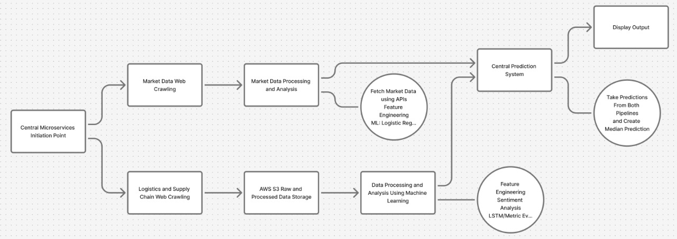
SYSTEM DESIGN
1. Web Crawler Service
- Function: Collects logistics, supply chain, and financial news from predefined sources and converts them into structured JSON documents.
- Process: Uses scheduled requests with rate limits and retries, extracts and cleans text, removes duplicates using URL/title hashes, and records metadata such as title, author, and timestamps.
- Output: Daily JSONL files with document ID, text, source, and metadata.
- Key Features: Fault-tolerant crawling with exponential backoff, scalable domain-based parallelism, compliance with site policies, and detailed per-run logging.
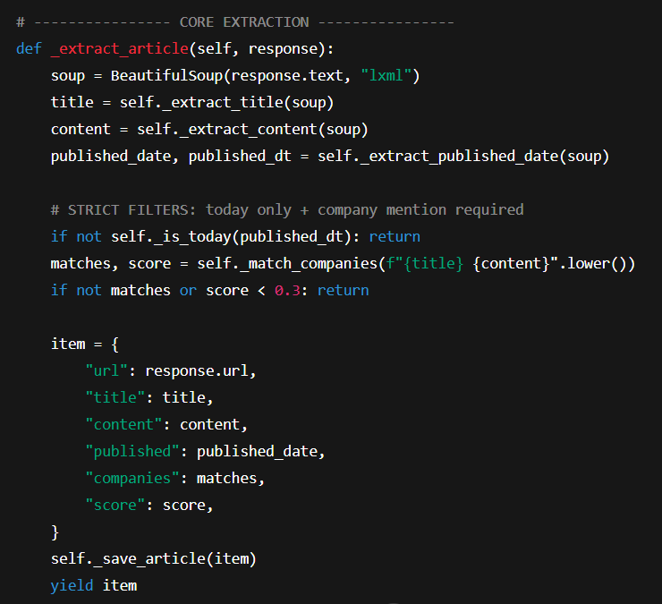

7

2. Data Processor Service
- Function: Converts raw news data into analyzable features using financial NLP.
- Process: Performs text normalization, language detection, sentiment scoring (FinBERT), and entity recognition for companies/products. Extracts key phrases and aggregates features like mean sentiment and news count per ticker per day.
- Output: Clean article-level and ticker-level feature tables.
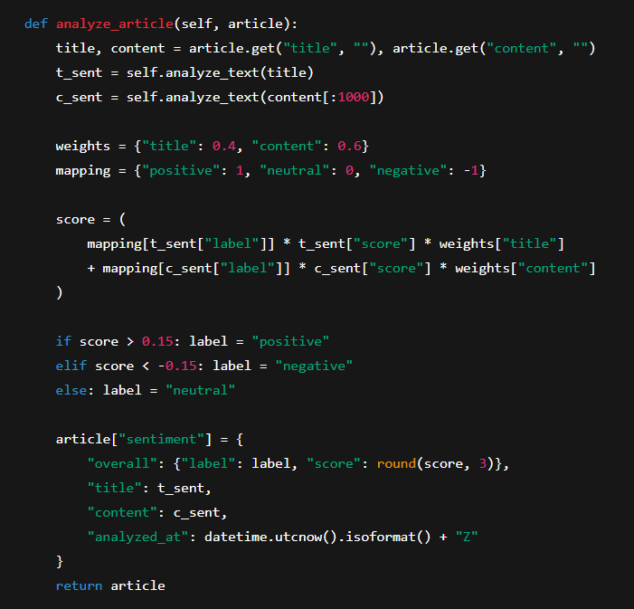
- Key Features: Parallelized NLP pipelines, cached models for speed, automatic error handling, and feature drift monitoring.

8

3. Cross-Cutting Design Notes

- Configuration: Centralized YAML/ENV configuration with per-service overrides.
- Data Contracts: Versioned schemas ensuring consistency across services.
- Scheduling: Lightweight cron-based orchestration with readiness checks.
- Idempotency: Temporary writes and atomic commits to prevent overwrites.
- Testing: Unit, integration, and contract tests across all modules.
- Monitoring: Structured logs, data-quality reports, and lightweight alerting

4. Market Data Service
- Function: Fetches financial market data (OHLCV) and computes technical indicators.
- Process: Retrieves prices via APIs like Yahoo Finance, validates data, calculates returns, volatility, and rolling averages, and adds optional RSI/MACD indicators.
- Output: Daily structured market tables with computed metrics.
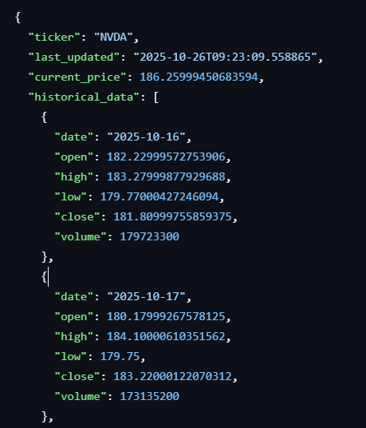
- Key Features: Parallel batch fetching, rate-limit handling, and automatic data validation for missing or anomalous entries.

9

5. Market Analyzer Service
- Function: Prepares refined market features for modeling and anomaly detection.
- Process: Standardizes features, removes outliers, reduces redundancy via correlation checks or PCA, and tags anomalies using z-scores or clustering.
- Output: Optimized per-ticker feature tables ready for model training.
- Key Features: Scalable vectorized operations, fallback logic for incomplete data, and daily feature-drift analysis.
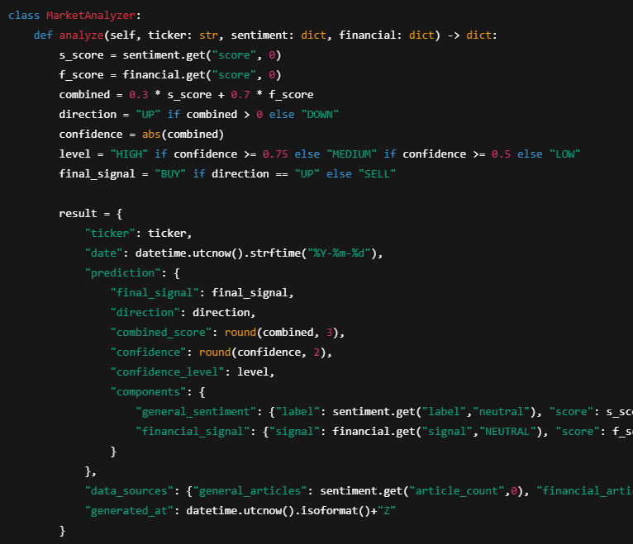
10

6. Predictor Service

- Function: Combines sentiment and market data to predict next-day stock direction.
- Process: Merges all features, applies supervised models (Logistic Regression, XGBoost, or LSTM), and explains predictions using SHAP or feature importances.
- Output: Per-ticker probability scores, classes (Up/Down), and reasons for predictions.
- Key Features: Time-series validation, adaptive retraining for drift, reproducible models, and daily accuracy tracking.
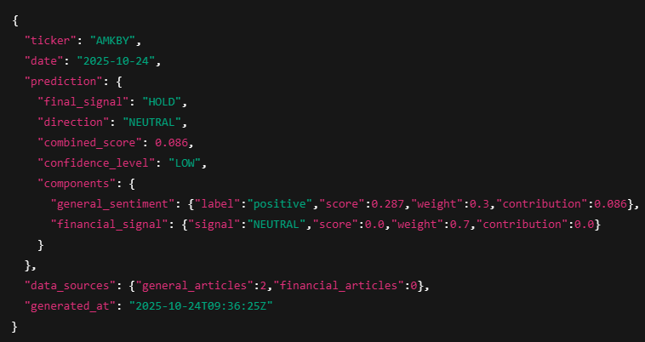

7. Dashboard Service
- Function: Displays predictions, insights, and model performance metrics.
- Process: Renders summary views, drill-down explanations, and historical comparisons through a web dashboard (Flask/FastAPI).
- Key Features: Cached data for speed, simple authentication, graceful degradation, and transparent operational logs.
11
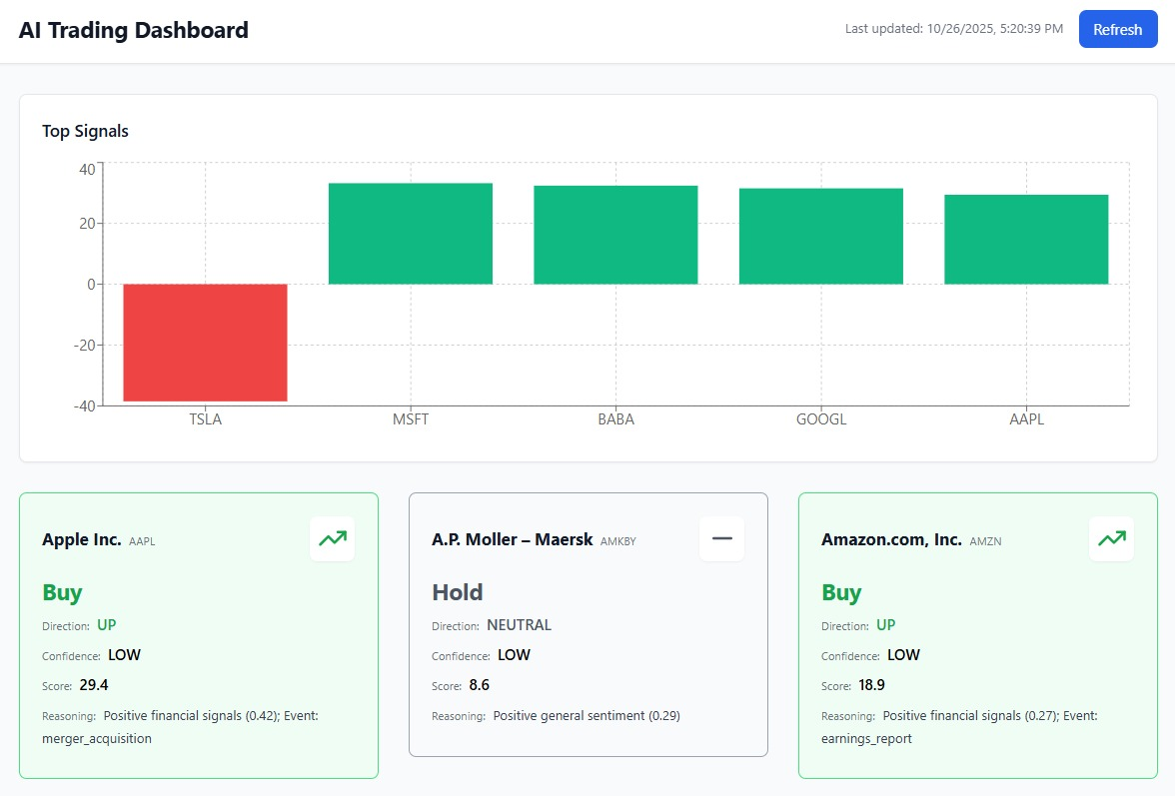
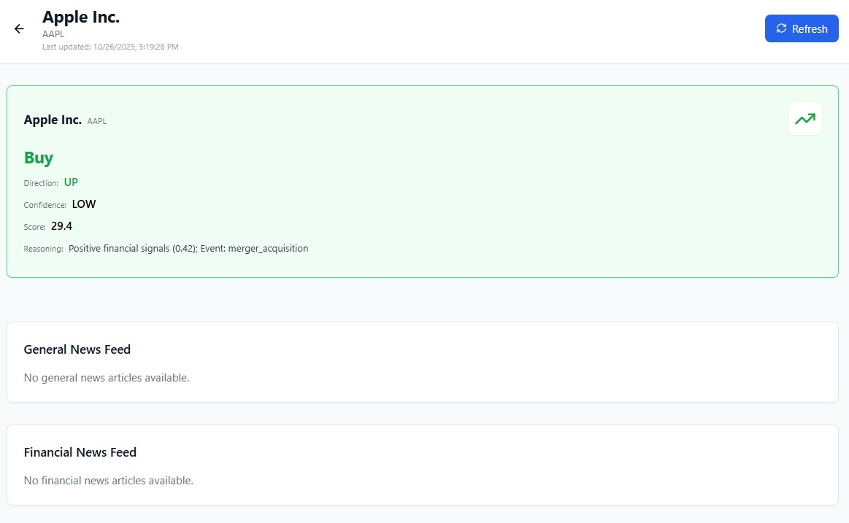
12

CHAPTER 5:

SYSTEM IMPLEMENTATION

1. Orchestration and scheduling

Use Docker Compose to define one container per microservice and one small scheduler container that triggers jobs on a timetable. Prefer cron in the scheduler or a tiny Python scheduler library. All services accept a run date and a mode such as backfill or daily so you can reprocess a specific day deterministically. Each stage writes a small readiness marker and a manifest file containing counts and checksums. The scheduler advances only when the required markers for the day exist. Keep configuration in a central configs folder with environment variables for secrets and per service YAML files for sources, tickers, and thresholds.

2. Web crawling

Build the crawler service with Scrapy or Requests HTML where Scrapy handles concurrency and retries well. Each spider reads a site configuration entry that defines start URLs, allowed domains, request headers, CSS or XPath selectors, and page pagination logic. Implement a pipeline that normalizes encodings, strips boilerplate, and removes tracking query parameters from URLs. Compute a URL hash for de duplication and drop duplicates within the run window. Persist raw output as JSONL with one document per line. Each record should include fields such as doc_id, url, source, title, text, published_ts, ingest_ts, lang_guess. Quarantine pages that fail parsing into a bad records folder. Respect robots and add polite rate limits, random delays, and user agent rotation. Expose a simple CLI such as python main.py run date 2025 10 16 source group logistics.

3. Data processing for text

The processor reads the last two to three days of raw documents. Use Pandas for tabular handling and spaCy or Hugging Face pipelines for tokenization and named entity recognition. For financial sentiment prefer FinBERT or a finance lexicon and record both a continuous score and a categorical label. Implement ticker linking in two passes: a fast gazetteer match and a second pass that uses context similarity to reduce false hits. Compute per article fields such as entities, keyphrases, sentiment, novelty against the recent window. Aggregate to per ticker per day features such as mean and standard deviation of sentiment, counts by label, counts of domain specific phrases like port congestion or delays. Write two outputs: a cleaned article table for audit and a per ticker feature table for modeling. Include a schema version and a processing stamps block in the file metadata.
13

Handling concept drift

Schedule periodic evaluation runs that compute rolling metrics over a trailing window and compare to a reference period. If accuracy or calibration drops below a threshold, schedule a retrain that refreshes the model on the latest data window. Keep at least one previous good model available and fail safe to it if a new model underperforms during a canary period.

5. Feature engineering on market data

Use ta or TA Lib for indicators when available and fall back to custom Pandas implementations when not. Start with a minimal stable set that works well on short windows: one day return, two and three day cumulative returns, rolling mean and standard deviation of returns over two and three day windows, a simple volatility proxy such as rolling standard deviation, and optionally RSI and MACD. Standardize features per ticker so the model does not learn scale artifacts. Clip or winsorize extreme values to reduce the effect of outliers. Produce a clear schema that lists every feature, its type, and the look back window used.

6. Model training and prediction

Treat the problem as binary classification for next-day direction, labeling 1 if close at t+1 > close at t, and build a training set by merging market and text features on ticker/date with strict temporal rules to prevent leakage. Use Logistic Regression as a baseline, add LightGBM for nonlinear signals with early stopping, apply TimeSeriesSplit or walk-forward CV, limit look-back to recent days, and persist model artifacts with version, training window, features, and metrics; for production, load the latest approved model and output class, probability, and model version.

7. Market data acquisition

Use finance or Alpha Vantage to fetch daily OHLCV for the requested tickers. Keep a local symbol map with canonical tickers and exchanges. Fetch the last five trading days during intra day runs and a longer window during backfills. Validate chronology, filter non trading days, and handle splits or missing values explicitly. Compute log returns and convert all timestamps to UTC. Write a partitioned Parquet dataset indexed by date and ticker. Include a manifest with the number of rows per ticker and the date range covered. Add simple rate limit handling with jitter and backoff and persist the last successful payload to a small cache so a short provider outage does not block the day.
14

8. Explainability

For linear models report standardized coefficients and for tree models compute SHAP values. Store per prediction top contributing features with their SHAP magnitude and sign. For news based contributions include the supporting headline, URL, and timestamp when a text feature is among the top drivers. Generate a compact daily summary that lists the most influential global features and any shifts compared to the previous week. Persist explanation artifacts next to the predictions so the dashboard can load them without re-computation.

9. Visualization and API

Implement a small FastAPI or Flask app that reads the latest prediction partition and exposes two endpoints: a table of per ticker predictions with probabilities and a detail endpoint that returns reasons for a selected ticker and date. The web view shows a daily summary with top predicted movers and confidence, a per ticker chart of recent predictions versus realized moves, and a reasons panel with indicators and news snippets. Cache the latest day in memory to reduce file reads and include a health endpoint that reports last successful run times per service.

10. Runtime, configuration, logging, and tests

Run everything locally with Docker Compose. Each service has a Dockerfile, a requirements file, a clear entry point, and its own log. Use structured logging with timestamps, service name, run date, and correlation ids where available. Keep configuration in a configs directory with environment specific overlays and a single .env template for secrets. Create unit tests for parsers, NLP functions, indicator calculations, feature assembly, and model utilities. Add an integration test that executes the full pipeline for a small fixture day with two tickers and two articles then validates that all expected partitions, schemas, and markers are produced. Include contract tests that validate schemas before downstream consumption. This discipline gives you reproducibility, quick debugging, and confidence that daily operations will complete on time.

15

CHAPTER 6:
TESTING

1. Strategy and Scope
- Testing ensures the overall correctness, robustness, and interpretability of all microservices in the Financial Market Prediction System.
- The test strategy covers the following dimensions:
- Code correctness – verifying individual functions and components.
- Service interoperability – validating smooth interaction between microservices.
- Model performance and validity – ensuring predictive models are accurate and unbiased.
- Scalability and load tolerance – confirming system stability under high load.
- Reproducibility – guaranteeing consistent results across multiple runs.

2. Test Data Management
- Create small, controlled test datasets with a few tickers and news articles.
- Use mock data for APIs (e.g., saved JSON responses from yfinance or scraped sites).
- Maintain golden datasets for regression testing, ensuring reproducible outputs.
- Store test data within a version-controlled directory to ensure consistent results across runs.
16

3. Unit Testing per Service
- Each service is tested independently using frameworks like pytest or unittest.
  - Web Crawler Service
  - Validate HTML extraction logic using sample pages.
  - Check de-duplication (URL or title hashing).
  - Test pagination and error-handling for missing elements.
- Data Processor Service
  - Verify text cleaning and tokenization on multilingual and malformed inputs.
  - Ensure correct sentiment detection using FinBERT for known positive/negative sentences.
  - Validate named-entity recognition and ticker-linking precision.
  - Confirm numerical aggregation (mean sentiment, article counts, etc.) per company.
- Market Data Service
  - Test API response handling and data formatting.
  - Verify OHLCV alignment, missing-value handling, and return calculations.
  - Validate computed indicators like RSI, MACD, and moving averages.
- Market Analyzer Service
  - Check correlation filtering and removal of redundant indicators.
  - Validate anomaly detection logic using synthetic extreme values.
  - Ensure feature standardization and scaling maintain data consistency.
- Predictor Service
  - Confirm data merging logic and time consistency (no look-ahead bias).
  - Test model inference consistency using fixed seed values.
  - Validate probability and class output formats.
- Dashboard Service
  - Ensure endpoints return correct JSON/HTML responses.
  - Validate filtering, pagination, and visualization rendering.
  - Test error-handling for missing or delayed predictions.
17

4. Contract and Schema Testing
- Validate every dataset (raw, processed, market, predictions) against a defined schema.
- Ensure field names, types, and nullability are consistent.
- Reject or quarantine invalid data.
- Include schema versioning to detect backward-incompatible changes.

5. Integration Testing
- Execute an end-to-end test covering the full data flow.
- Run a controlled daily pipeline (crawl → process → analyze → predict).
- Validate data flow order, schema consistency, and correct readiness markers.
- Verify the final prediction file structure, model version, and timestamps.

6. Model Validation
- Use time-series cross-validation to avoid look-ahead bias.
- Evaluate with metrics: accuracy, precision, recall, F1-score, ROC-AUC.
- Calibrate probability outputs using Platt scaling or isotonic regression.
- Compare SHAP or feature-importance outputs with expected drivers to ensure interpretability.

7. Performance and Load Testing
- Simulate high-load scenarios with multiple tickers and concurrent crawls.
- Monitor resource usage (CPU, memory, I/O) across containers.
- Validate processing times meet end-of-day prediction deadlines.
- Identify and eliminate bottlenecks using profiling tools.

8. Reliability and Regression Testing
- Conduct re-runs of previous days to confirm deterministic outputs.
- Compare new outputs to historical ones to detect silent model drift.
- Maintain a baseline performance report to track changes in accuracy and latency.
- Use a version-controlled “golden dataset” for automated regression checks.
18

9. Continuous Integration (CI/CD)
- Integrate all tests into a CI pipeline (e.g., GitHub Actions or Jenkins).
- Automatically run unit, schema, and model validation tests on every commit.
- Prevent deployment if any critical test or metric threshold fails.
- Store artifacts (logs, metrics, test reports) for traceability.

10. Reporting and Monitoring
- Implement automated logging (structured logs with timestamps/IDs) and daily quality reports covering data volume, data quality (missing ratios), and model performance (accuracy/drift).
- Configure immediate alerts for failures, schema issues, or prediction delays.
- Ensures the system delivers reliable, reproducible, and explainable stock predictions under all operating conditions.

19

CONCLUSION

In conclusion, the Cloud-Native News and Supply Chain Data-Driven Financial Market Prediction System demonstrates a forward-looking approach to financial forecasting by integrating heterogeneous data sources — including structured market indicators, logistics data, and unstructured financial news — into a unified and intelligent analytics framework. Through the use of microservice-based architecture, the system overcomes the limitations of traditional monolithic models, offering scalability, flexibility, and modularity for real-time operations. By leveraging AWS S3 as a centralized data repository within a Bronze–Silver–Gold data lake hierarchy, the platform ensures end-to-end data traceability, governance, and reproducibility. The inclusion of LightGBM for numerical data modeling and FinBERT for sentiment analysis provides a comprehensive fusion of quantitative and qualitative insights. Furthermore, the use of SHAP (SHapley Additive Explanations) brings transparency to model decision-making, improving interpretability and stakeholder trust in predictions. This system’s cloud-native, containerized design enables independent deployment and scaling of each microservice, facilitating continuous integration and delivery in production environments. Overall, the project successfully achieves its goal of building a scalable, explainable, and adaptive financial prediction pipeline capable of evolving with market dynamics and diverse data sources.
20

FUTURE ENHANCEMENTS

Future enhancements could focus on real-time responsiveness and broader market coverage. Integrating streaming technologies like Apache Kafka or AWS Kinesis would enable continuous ingestion of news and market data for instant predictions. Expanding beyond stocks to include commodities, forex, and cryptocurrencies would make the system a more comprehensive financial forecasting tool. Advanced models such as transformer-based architectures or reinforcement learning agents could further improve adaptability by optimizing strategies based on live market feedback. Additional improvements could enhance usability, operational efficiency, and security. Developing an interactive dashboard with visual analytics, alerts, and explainability summaries would make insights more actionable. Incorporating an MLOps pipeline for automated drift detection, retraining, and deployment would maintain prediction accuracy with minimal manual effort. Finally, integrating role-based access control, data encryption, and auditable pipelines would ensure compliance with financial regulations and protect sensitive data, creating a secure, intelligent, and self-adaptive forecasting ecosystem.
21

BIBLIOGRAPHY

[1] A. Nassirtoussi, S. Aghabozorgi, T. W. Yee, and D. Chek Ling, “Text mining for market prediction: A systematic review,” Expert Systems with Applications, vol. 41, no. 16, pp. 7653–7670, 2014.

[2] Y. Ding, Y. Zhang, and J. Liu, “Deep learning for event-driven stock prediction,” in Proc. 25th Int. Joint Conf. Artificial Intelligence (IJCAI), pp. 2327–2333, 2016.

[3] J. Devlin, M. Chang, K. Lee, and K. Toutanova, “BERT: Pre-training of deep bidirectional transformers for language understanding,” in Proc. NAACL-HLT, pp. 4171–4186, 2019.

[4] Amazon Web Services, “Amazon S3 Developer Guide,” AWS Documentation, 2024. [Online]. Available: https://docs.aws.amazon.com/s3

[5] M. Zhang, S. Chen, and X. Zhao, “Hybrid news and numerical data-driven stock trend prediction using LSTM,” IEEE Access, vol. 9, pp. 39612–39620, 2021.

[6] S. Fischer, C. Krauss, and F. Deinert, “Deep learning with long short-term memory networks for financial market predictions,” European Journal of Operational Research, vol. 270, no. 2, pp. 654–669, 2018.

[7] N. Soni, S. Sharma, and N. Singh, “Predictive analysis of stock market using machine learning techniques,” International Journal of Computer Applications, vol. 132, no. 12, pp. 7–9, 2015.

[8] M. Chen, Z. Mao, and Y. Liu, “Microservice architecture for big data analysis in cloud computing,” IEEE Access, vol. 8, pp. 123518–123529, 2020.

[9] D. Taibi and V. Lenarduzzi, “On the definition of microservice bad smells,” IEEE Software, vol. 35, no. 3, pp. 56–62, 2018.
22

[10] G. E. Hinton and R. R. Salakhutdinov, “Reducing the dimensionality of data with neural networks,” Science, vol. 313, no. 5786, pp. 504–507, 2006.

[11] T. Mikolov, K. Chen, G. Corrado, and J. Dean, “Efficient estimation of word representations in vector space,” arXiv:1301.3781, 2013.

[12] F. Chollet, “Keras: The Python deep learning library,” Astrophysics Source Code Library, record ascl:1806.022, 2018.

[13] X. Zhang and J. Skiena, “Trading strategies to exploit blog and news sentiment,” in Proc. 4th Int. AAAI Conf. Weblogs and Social Media, pp. 375–378, 2010.

[14] S. Hochreiter and J. Schmidhuber, “Long short-term memory,” Neural Computation, vol. 9, no. 8, pp. 1735–1780, 1997.

[15] Google Cloud, “Building scalable machine learning pipelines with microservices,” Google Cloud Whitepaper, 2023.

[16] P. K. Jain and R. K. Jain, “Design and implementation of an automated stock prediction system using deep learning and cloud computing,” International Journal of Advanced Computer Science and Applications, vol. 12, no. 8, pp. 355–362, 2021.

[17] S. Zhang, Q. Zhang, and H. Chen, “Cloud-native microservice deployment and orchestration: A survey,” IEEE Access, vol. 10, pp. 81945–81964, 2022.

[18] R. Collobert and J. Weston, “A unified architecture for natural language processing: Deep neural networks with multitask learning,” in Proc. ICML, pp. 160–167, 2008.

[19] A. Vaswani et al., “Attention is all you need,” in Advances in Neural Information Processing Systems (NeurIPS), 2017.
23

[20] D. Reinsel, J. Gantz, and J. Rydning, “The Digitization of the World from Edge to Core,” IDC White Paper, 2018.

[21] A. Bollen, H. Mao, and X. Zeng, “Twitter mood predicts the stock market,” Journal of Computational Science, vol. 2, no. 1, pp. 1–8, 2011.

[22] H. Xu, Y. Li, and S. Zhou, “Stock movement prediction based on graph neural networks and news sentiment,” IEEE Access, vol. 10, pp. 145123–145132, 2022.

[23] M. A. Ferris and C. Clifford, “An architecture for scalable cloud data pipelines using AWS Lambda and S3,” IEEE Cloud Computing, vol. 9, no. 3, pp. 45–53, 2022.

[24] S. K. Roy and P. K. Paul, “Design of a real-time data ingestion framework using Apache Kafka and cloud storage for big data analytics,” IEEE Transactions on Big Data, vol. 9, no. 1, pp. 112–121, 2023.

[25] Z. Zhang, H. Li, and T. Sun, “Multi-modal fusion for stock prediction with financial news and numerical data,” IEEE Transactions on Neural Networks and Learning Systems, vol. 34, no. 5, pp. 2480–2491, 2023.
24

